Sarsfield Community Association (SCA) Inc.
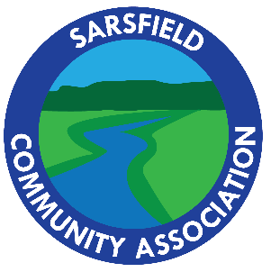
SCA Committee Nomination Form 2022
Nominations are called for the following positions:
- President (1)
- Vice President (1)
- Secretary (1)
- Assistant Secretary (1)
- Treasurer (1)
- Ordinary Committee Member (Number to be determined at the AGM)
To nominate for committee, please complete your nomination information below:
Position:
Name:
Signature:
Important: Only Sarsfield Community Association (SCA) members are eligible to nominate.
Your SCA membership status will be checked 10 days prior to the AGM.
Are you a SCA |  | Yes |  | No
member? | Please fill your contact info below |  | Please complete membership online at: https://sarsfield.com.au and fill in your contact info below
Address:
Phone number:
Email Address:
Please submit your form by
Via email (enquiries@sarsfield.com.au) or post (SCA letterbox, 10 School Road, Sarsfield).

The Annual General Meeting of the Association will be held 6pm, Friday 25 November 2022
at Sarsfield Hall, 10 School Road, Sarsfield.
The Sarsfield Community’s monthly Friday Night Feed will follow the AGM.

Did you know you can also nominate for SCA committee online at www.sarsfield.com.au?

